Ideation Phase
Define the Problem Statements

Date | 30 September 2026
Team ID | SWTID-2026-8886
Project Name | Implement Client Script and UI Policy for Incident
Maximum Marks | 2 Marks

Customer Problem Statement Template:
Create a problem statement to understand your customer's point of view. The Customer Problem Statement template helps you focus on what matters to create experiences people will love.
A well-articulated customer problem statement allows you and your team to find the ideal solution for the challenges your customers face. Throughout the process, you’ll also be able to empathize with your customers, which helps you better understand how they perceive your product or service.
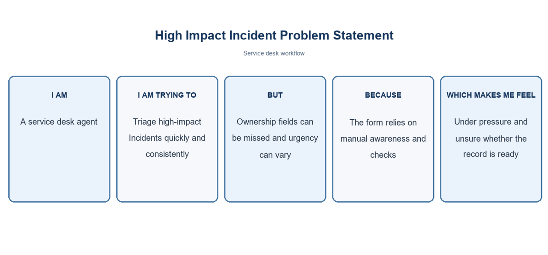
Reference: https://miro.com/templates/customer-problem-statement/
Example:
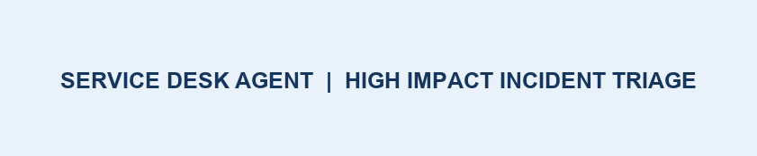
Problem Statement (PS) | I am (Customer) | I’m trying to | But | Because | Which makes me feel
PS-1 | Service desk agent | Triage high-impact Incidents consistently | Routing may be incomplete | Form relies on manual checks | Under pressure and uncertain the record is ready
PS-2 | Incident manager | Keep triage records complete | State can be changed from a list without context | The full form workflow is bypassed | Concerned about inconsistent audit and reporting

Project note: values use the standard Incident choices where Impact 1 and Urgency 1 represent High. Confirm field names and values in the target instance.

